Software Requirements
Specification

for

PetroPulse
Petrol Station
Management System

Prepared by

Anas Bin Rashid 22I-0907
Adan Malik 22I-1000
Hasnain Akhtar 22I-1241

April 20, 2025

Product Backlog/User Stories

ID | User Story | Acceptance Criteria | Estimation | Priority
1 | User Registration - As a new user, I want to register on the system so that I can access PetroPulse services. | Given: A new user navigates to the registration page. When: They provide valid details (name, email, phone, password). Then: The system successfully creates an account and sends a confirmation email. | 3 | High
2 | User Login - As a registered user, I want to log into the system so that I can access my dashboard. | Given: A user is on the login page. When: They enter valid credentials. Then: The system grants access to their dashboard. | 2 | High
3 | Password Reset - As a user, I want to reset my password so that I can regain access to my account if I forget it. | Given: A user is on the login page. When: They click on "Forgot Password" and enter their email. Then: The system sends a password reset link to their email. | 3 | Medium
4 | Add Fuel Station - As an owner, I want to add new fuel stations so that I can manage multiple stations in the system. | Given: An owner is logged in. When: They enter station details and submit the form. Then: The system registers the new station and updates the list. | 3 | High
5 | View Fuel Stations - As an owner, I want to view a list of my fuel stations so that I can manage their operations efficiently. | Given: The owner is on the dashboard. When: They navigate to the "Manage Stations" section. Then: The system displays a list of owned stations. | 2 | High
6 | Update Fuel Station Details - As an owner, I want to update my fuel station details so that I can keep the information accurate. | Given: The owner is on the "Manage Stations" page. When: They update station details and save changes. Then: The system reflects the updated details. | 3 | Medium
7 | Remove Fuel Station - As an owner, I want to remove a fuel station so that I can stop managing a closed or sold station. | Given: The owner is on the "Manage Stations" page. When: They click delete and confirm the action. Then: The system removes the station from the database. | 3 | Medium
8 | Register Workers - As a station owner, I want to register workers so that they can manage station activities. | Given: The owner is on the "Manage Workers" page. When: They enter the worker's details and submit. Then: The system registers the worker. | 3 | High
9 | Assign Workers to Stations - As an owner, I want to assign workers to specific stations so that they can operate in their designated locations. | Given: An owner is on the worker management page. When: They select a worker and assign a station. Then: The system updates the worker's assigned station. | 3 | Medium
10 | Worker Login - As a worker, I want to log into the system so that I can manage station operations. | Given: A worker is on the login page. When: They enter valid credentials. Then: The system grants access to the worker dashboard. | 2 | High
11 | Record Fuel Sales - As a worker, I want to record fuel sales so that the system tracks all transactions. | Given: A worker is logged in. When: They enter fuel sale details. Then: The system stores the transaction. | 3 | High
12 | Generate Sales Reports - As an owner, I want to generate sales reports so that I can analyze revenue and performance. | Given: The owner is on the reports page. When: They select a date range and generate a report. Then: The system displays the sales data. | 3 | High
13 | Track Fuel Inventory - As a station owner, I want to track fuel levels so that I can ensure continuous supply. | Given: The owner is on the dashboard. When: They check the station inventory. Then: The system displays real-time fuel levels. | 4 | High
14 | Alert for Low Fuel Levels - As a station owner, I want to receive alerts for low fuel levels so that I can order refills in time. | Given: A station's fuel level drops below a threshold. When: The system detects the low level. Then: It sends an alert to the owner. | 3 | High
15 | Order Fuel Supply - As an owner, I want to order fuel refills so that my stations never run out of stock. | Given: The owner is on the fuel supply page. When: They place an order for fuel. Then: The system processes and confirms the order. | 4 | High
16 | View Loyalty Points - As a customer, I want to view my loyalty points so that I can track my rewards. | Given: A customer is logged in. When: They navigate to the "Loyalty Points" page. Then: The system displays their current balance. | 2 | Medium
17 | Redeem Loyalty Points - As a customer, I want to redeem my loyalty points so that I can get fuel discounts. | Given: A customer has sufficient points. When: They redeem them at checkout. Then: The system applies the discount. | 3 | Medium
18 | Customer Fuel Purchase - As a customer, I want to purchase fuel from the station so that I can refuel my vehicle. | Given: A customer is at a station. When: They choose the fuel type, quantity, and payment method. Then: The system processes the payment and updates inventory. | 4 | High
19 | Manage Pricing for Fuel Types - As a station owner, I want to update fuel prices so that I can adjust them based on market conditions. | Given: The owner is on the pricing page. When: They update the price of a fuel type. Then: The system reflects the new pricing in real time. | 3 | High
20 | Manage Maintenance Requests - As a station owner, I want to log maintenance requests so that I can ensure station upkeep. | Given: A station has an issue. When: The owner submits a maintenance request. Then: The system records and tracks the request. | 3 | Medium
21 | View Transaction History - As a customer, I want to view my transaction history, so that I can track my fuel purchases. | Given: A customer is logged in,  When: They navigate to the transactions section,  Then: The system displays all past fuel purchases. | 2 | Medium
22 | Payment via Cash - As a customer, I want to pay for fuel using cash, so that I can complete my purchase without a card. | Given: A customer selects fuel,  When: They choose cash as the payment method,  Then: The system registers the payment and updates records. | 3 | High
23 | Payment via Card - As a customer, I want to pay for fuel using my debit/credit card, so that I can make transactions easily. | Given: A customer selects fuel,  When: They choose card as the payment method,  Then: The system processes the payment and updates records. | 3 | High
24 | Manage Supplier Information - As an owner,  I want to manage my fuel suppliers,  So that I can track orders and deliveries. | Given: The owner is on the supplier management page,  When: They add, edit, or remove a supplier,  Then: The system updates the supplier database. | 3 | Medium
25 | Generate Maintenance Reports - As an owner,  I want to track station maintenance, so that I can schedule repairs and ensure smooth operations. | Given: The owner is on the reports page,  When: They request a maintenance report,  Then: The system provides a list of past and upcoming maintenance tasks. | 3 | Medium
26 | Employee Attendance Tracking - As a station owner,  I want to track employee attendance, so that I can monitor working hours. | Given: A worker logs into the system,  When: They mark attendance for the shift,  Then: The system records their working hours. | 3 | Medium
27 | Secure Access - As a user,  I want to have secure access to system configurations, so that I can manage system settings safely. | Given: The user is on the login page,  When: They enter valid admin credentials,  Then: The system grants access to the admin panel. | 3 | High
28 | View Worker Profiles - As an owner, I want to view worker profiles, so I can manage their information and roles. | Given: The owner is on the "Manage Workers" page. When: They select a worker profile. Then: The system displays the worker's details. | 2 | Medium

Team Member Roles

Product Owner – Hasnain Akhtar
Responsibilities:
- Define and prioritize user stories for the Petroleum Management System.
- Ensure that features such as fuel request handling, inventory tracking, and payment processing align with stakeholder needs.
- Communicate business requirements clearly to the development team.
- Accept or reject completed user stories based on their adherence to acceptance criteria.
- Continuously refine the backlog based on feedback from stakeholders and the development team.

Scrum Master – Anas Bin Rashid
Responsibilities:
- Facilitate Agile ceremonies such as Sprint Planning, Daily Standups, Sprint Review, and Retrospective.
- Identify and remove blockers affecting the development of features like shift management, employee check-in, and real-time alerts.
- Ensure smooth collaboration between Hasnain (Product Owner) and Adan (Developer).
- Track sprint progress and ensure adherence to Agile principles.
- Guide the team in improving workflow efficiency and maintaining high productivity.

Scrum Team – Adan Malik, Anas Bin Rashid, Hasnain Akhtar
Responsibilities:
- Develop and implement features such as fuel request processing, analytics dashboard, and customer profile management.
- Ensure code quality, security, and efficiency while integrating various modules.
- Conduct unit testing and debugging to ensure smooth system functionality.
- Collaborate with Hasnain (Product Owner) to clarify feature requirements and address feedback.
- Participate in sprint planning and daily standups to track development progress.

Sprint Details

Total number of Sprints are 3, and their details are as follows.

Sprint 1

1. Sprint Overview
- Objective : The goal of Sprint 1 was to lay the foundation for the PetroPulse system by implementing core user authentication features and ensuring secure access for all user roles.
- Scope of Work :
  - User registration and login functionality.
  - Password reset feature.
  - Worker login for managing station operations.
  - Secure access control for admin configurations.
- Duration : 2 weeks

2. Sprint Backlog
Modules Worked On
- User Authentication (Owner, Worker, Customer roles)
- Secure Access Control
User Stories and Sub-User Stories
User Story 1 – User Registration
Title : User Registration
As a new user , I want to register on the system so that I can access PetroPulse services.
Context / Note : This story ensures that new users can create accounts with valid details (name, email, phone, password).
This story is related to Sprint #1.
Task :
- Create registration form.
- Validate input fields before submission.
- Store user data in the database.
- Send confirmation email upon successful registration.
Subtask List :
- [Create registration form UI]
- [Validate input fields (email, password, phone)]
- [Store user data in MongoDB]
- [Send confirmation email via SMTP]
Associated User Stories :
- User Story 2 : User Login
- Rule : A user cannot register with an existing email.
- ID : US-01

User Story 2 – User Login
Title : User Login
As a registered user , I want to log into the system so that I can access my dashboard.
Context / Note : This story ensures that registered users can securely log in using their credentials.
This story is related to Sprint #1.
Task :
- Create login form.
- Authenticate credentials against the database.
- Redirect authenticated users to their respective dashboards.
Subtask List :
- [Create login form UI]
- [Authenticate credentials using bcrypt]
- [Redirect users to dashboard based on role]
Associated User Stories :
- User Story 3 : Password Reset
- Rule : Invalid credentials must display an error message.
- ID : US-02

User Story 3 – Password Reset
Title : Password Reset
As a user , I want to reset my password so that I can regain access to my account if I forget it.
Context / Note : This story provides a "Forgot Password" option for users to reset their passwords via email.
This story is related to Sprint #1.
Task :
- Add "Forgot Password" option on the login page.
- Implement email verification for password reset requests.
- Allow users to set a new password using the reset link.
Subtask List :
- [Add "Forgot Password" button]
- [Send password reset link via email]
- [Allow users to set a new password]
Associated User Stories :
- User Story 2 : User Login
- Rule : Password reset links must expire after 24 hours.
- ID : US-03

User Story 10 – Worker Login
Title : Worker Login
As a worker , I want to log into the system so that I can manage station operations.
Context / Note : This story ensures that workers can securely log in and access their operational dashboard.
This story is related to Sprint #1.
Task :
- Create a separate login form for workers.
- Authenticate worker credentials.
- Redirect workers to their operational dashboard.
Subtask List :
- [Create worker login form UI]
- [Authenticate worker credentials]
- [Redirect to worker dashboard]
Associated User Stories :
- User Story 27 : Secure Access
- Rule : Workers must have role-based access to specific features.
- ID : US-10

User Story 27 – Secure Access
Title : Secure Access
As a user , I want to have secure access to system configurations so that I can manage system settings safely.
Context / Note : This story ensures that only authorized users can access admin panels and sensitive configurations.
This story is related to Sprint #1.
Task :
- Implement role-based access control (RBAC).
- Restrict admin panel access to authorized users only.
- Log all access attempts for auditing purposes.
Subtask List :
- [Implement RBAC middleware]
- [Restrict access to admin routes]
- [Log access attempts in the database]
Associated User Stories :
- User Story 10 : Worker Login
- Rule : Unauthorized access attempts must trigger alerts.
- ID : US-27

3. Software Testing
Login Page: Test Design
Fields:
- Email
- Password
Field-Wise Analysis and Test Design (Login)
Field | Input Criteria | Valid Equivalence Class | Invalid Equivalence Class | Boundary Values
Email | Valid email format | user@example.com | Missing @, invalid domain, etc. | Structure-based, no length boundary
Password | 8–20 characters | Length 8–20, any characters | Less than 8 or more than 20 characters | 7 (invalid), 8 (valid), 20 (valid), 21 (invalid)

Weak Equivalence Class Testing (Login)
Field | Test Case ID | Test Input | Expected Result | Remarks
Email | LOGIN-ECT-WEAK-01 | john.doe@mail.com | Accepted | Valid email format
Email | LOGIN-ECT-WEAK-02 | johnmail.com | Rejected | Missing @ symbol
Password | LOGIN-PWD-WEAK-01 | LoginPass1! | Accepted | Valid password length
Password | LOGIN-PWD-WEAK-02 | short | Rejected | Too short

Strong Equivalence Class Testing (Login)
Field | Test Case ID | Test Input | Expected Result | Remarks
Email | LOGIN-ECT-STRONG-01 | valid@example.com | Accepted | Correct format
Email | LOGIN-ECT-STRONG-02 | invalidemail.com | Rejected | Missing @
Email | LOGIN-ECT-STRONG-03 | @domain.com | Rejected | Missing local part
Email | LOGIN-ECT-STRONG-04 | user@.com | Rejected | Incomplete domain
Password | LOGIN-PWD-STRONG-01 | Pass1234 | Accepted | Exactly 8 characters
Password | LOGIN-PWD-STRONG-02 | StrongPassword12345678 | Accepted | Exactly 20 characters
Password | LOGIN-PWD-STRONG-03 | Short1 | Rejected | 7 characters
Password | LOGIN-PWD-STRONG-04 | TooLongPasswordInputText | Rejected | >20 characters

Boundary Value Analysis (Login)
Password Length (8–20)
Test Case ID | Input Length | Test Input | Expected Result | Remarks
LOGIN-BVA-PWD-01 | 7 | Pass123 | Rejected | Below valid range
LOGIN-BVA-PWD-02 | 8 | Pass1234 | Accepted | Lower boundary
LOGIN-BVA-PWD-03 | 20 | PasswordLenExactly20!! | Accepted | Upper boundary
LOGIN-BVA-PWD-04 | 21 | TooLongPassword21Text | Rejected | Just above upper limit

Summary (Login)
- Weak EC Tests: 4
- Strong EC Tests: 8
- BVA Tests: 4
- Total Test Cases (Login): 16

Signup Page: Test Design
Fields:
- Email
- Password
- Phone Number
- Name
- Username

Field-Wise Analysis and Test Design (Signup)
Field | Input Criteria | Valid Equivalence Class | Invalid Equivalence Class | Boundary Values
Email | Valid email format | user@example.com | Missing @, invalid domain | Structure-based
Password | 8–20 characters | Valid length, any characters | <8 or >20 characters | 7 (invalid), 8 (valid), 20 (valid), 21 (invalid)
Phone Number | Exactly 10 digits, numeric only | 1234567890 | <10, >10 digits, letters | 9 (invalid), 10 (valid), 11 (invalid)
Name | Alphabetic only, 1–50 characters | John Doe | Contains numbers/symbols, empty, >50 chars | 0 (invalid), 1 (valid), 50 (valid), 51 (invalid)
Username | Alphanumeric only, 4–15 characters | user123, Alpha | <4, >15 characters, special characters | 3 (invalid), 4 (valid), 15 (valid), 16 (invalid)

Weak Equivalence Class Testing (Signup)
Field | Test Case ID | Test Input | Expected Result | Remarks
Email | SIGNUP-ECT-WEAK-01 | new.user@mail.com | Accepted | Valid format
Email | SIGNUP-ECT-WEAK-02 | useratmail.com | Rejected | Missing @
Password | SIGNUP-PWD-WEAK-01 | SignupPass1 | Accepted | Valid
Password | SIGNUP-PWD-WEAK-02 | 123 | Rejected | Too short
Phone Number | SIGNUP-PHN-WEAK-01 | 9876543210 | Accepted | Valid 10-digit number
Phone Number | SIGNUP-PHN-WEAK-02 | 12345abcde | Rejected | Contains letters
Name | SIGNUP-NAM-WEAK-01 | Alice | Accepted | Valid name
Name | SIGNUP-NAM-WEAK-02 | John123 | Rejected | Contains digits
Username | SIGNUP-USR-WEAK-01 | user01 | Accepted | Valid
Username | SIGNUP-USR-WEAK-02 | us! | Rejected | Too short, invalid char

Strong Equivalence Class Testing (Signup)
Field | Test Case ID | Test Input | Expected Result | Remarks
Email | SIGNUP-ECT-STRONG-01 | user@domain.com | Accepted | Valid email
Email | SIGNUP-ECT-STRONG-02 | nodomain@ | Rejected | Invalid domain
Email | SIGNUP-ECT-STRONG-03 | @nodomain.com | Rejected | Missing local part
Email | SIGNUP-ECT-STRONG-04 | user@.com | Rejected | Invalid domain format
Password | SIGNUP-PWD-STRONG-01 | Pass1234 | Accepted | Exactly 8 characters
Password | SIGNUP-PWD-STRONG-02 | Pass123456789012345! | Accepted | Exactly 20 characters
Password | SIGNUP-PWD-STRONG-03 | Short1 | Rejected | Only 7 characters
Password | SIGNUP-PWD-STRONG-04 | ThisPasswordIsTooLongToBeValid | Rejected | Over 20 characters
Phone Number | SIGNUP-PHN-STRONG-01 | 0123456789 | Accepted | 10-digit valid
Phone Number | SIGNUP-PHN-STRONG-02 | 987654321 | Rejected | 9 digits
Phone Number | SIGNUP-PHN-STRONG-03 | 12345678901 | Rejected | 11 digits
Phone Number | SIGNUP-PHN-STRONG-04 | 98abc12345 | Rejected | Contains characters
Name | SIGNUP-NAM-STRONG-01 | Emily | Accepted | Valid name
Name | SIGNUP-NAM-STRONG-02 | Tom123 | Rejected | Contains numbers
Name | SIGNUP-NAM-STRONG-03 | `` | Rejected | Empty
Name | SIGNUP-NAM-STRONG-04 | A repeated 51 times | Rejected | >50 characters
Username | SIGNUP-USR-STRONG-01 | user123 | Accepted | Valid
Username | SIGNUP-USR-STRONG-02 | u1 | Rejected | Too short
Username | SIGNUP-USR-STRONG-03 | user!name | Rejected | Contains special char
Username | SIGNUP-USR-STRONG-04 | averylongusernamethatisbad | Rejected | >15 characters

Boundary Value Analysis (Signup)
Password Length (8–20)
Test Case ID | Input Length | Test Input | Expected Result | Remarks
SIGNUP-BVA-PWD-01 | 7 | Sign123 | Rejected | Below lower boundary
SIGNUP-BVA-PWD-02 | 8 | Sign1234 | Accepted | Lower boundary
SIGNUP-BVA-PWD-03 | 20 | ValidPasswordLen20!! | Accepted | Upper boundary
SIGNUP-BVA-PWD-04 | 21 | TooLongPasswordText123 | Rejected | Just above max

Phone Number (10 digits)
Test Case ID | Input Length | Test Input | Expected Result | Remarks
SIGNUP-BVA-PHN-01 | 9 | 123456789 | Rejected | Below valid range
SIGNUP-BVA-PHN-02 | 10 | 1234567890 | Accepted | Valid boundary
SIGNUP-BVA-PHN-03 | 11 | 12345678901 | Rejected | Above valid range

Name Length (1–50)
Test Case ID | Input Length | Test Input | Expected Result | Remarks
SIGNUP-BVA-NAM-01 | 0 | `` | Rejected | Empty name
SIGNUP-BVA-NAM-02 | 1 | A | Accepted | Lower boundary
SIGNUP-BVA-NAM-03 | 50 | A repeated 50 times | Accepted | Upper boundary
SIGNUP-BVA-NAM-04 | 51 | A repeated 51 times | Rejected | Just above max

Username Length (4–15)
Test Case ID | Input Length | Test Input | Expected Result | Remarks
SIGNUP-BVA-USR-01 | 3 | usr | Rejected | Below valid range
SIGNUP-BVA-USR-02 | 4 | user | Accepted | Lower boundary
SIGNUP-BVA-USR-03 | 15 | username1234567 | Accepted | Upper boundary
SIGNUP-BVA-USR-04 | 16 | username12345678 | Rejected | Above valid range

Summary (Signup)
- Weak EC Tests: 10
- Strong EC Tests: 20
- BVA Tests: 15
- Total Test Cases (Signup): 45

4. Meetings Conducted
Sprint Planning Meeting
Overview :
a. Date Time Stamp : 1 March 2025
b. Attendees :
Present | Absent
Anas Bin Rashid | -
Adan Malik | -
Hasnain Akhtar | -

Topics Discussed and Conclusions Reached :
- Defined sprint goals: Implement user authentication and secure access features.
- Prioritized user stories: US-1, US-2, US-3, US-10, US-27.
- Assigned tasks to team members.
Conclusions :
- Sprint backlog finalized.
- Daily scrum schedule set for 9:00 AM daily.
Overall Duration : 1 hour

Daily Scrum Meetings
The meeting focused on different topics each day and they are reflected in the burndown chart below:
Day | Story Points Remaining (Planned) | Story Points Remaining (Actual) | Tasks Completed | Notes
Day 1 | 30 | 30 | 0 | Sprint starts; no tasks done.
Day 2 | 27 | 28 | 2 | Minor delays in setup.
Day 3 | 24 | 26 | 2 | UI design started.
Day 4 | 21 | 23 | 3 | Authentication UI completed.
Day 5 | 18 | 20 | 3 | Dashboard UI progress.
Day 6 | 15 | 17 | 3 | Minor bug fixes.
Day 7 | 12 | 14 | 3 | Inventory UI completed.
Day 8 | 9 | 11 | 3 | Testing ongoing.
Day 9 | 6 | 8 | 3 | Leftover tasks identified.
Day 10 | 0 | 3 | 5 | Sprint ends; some tasks left.

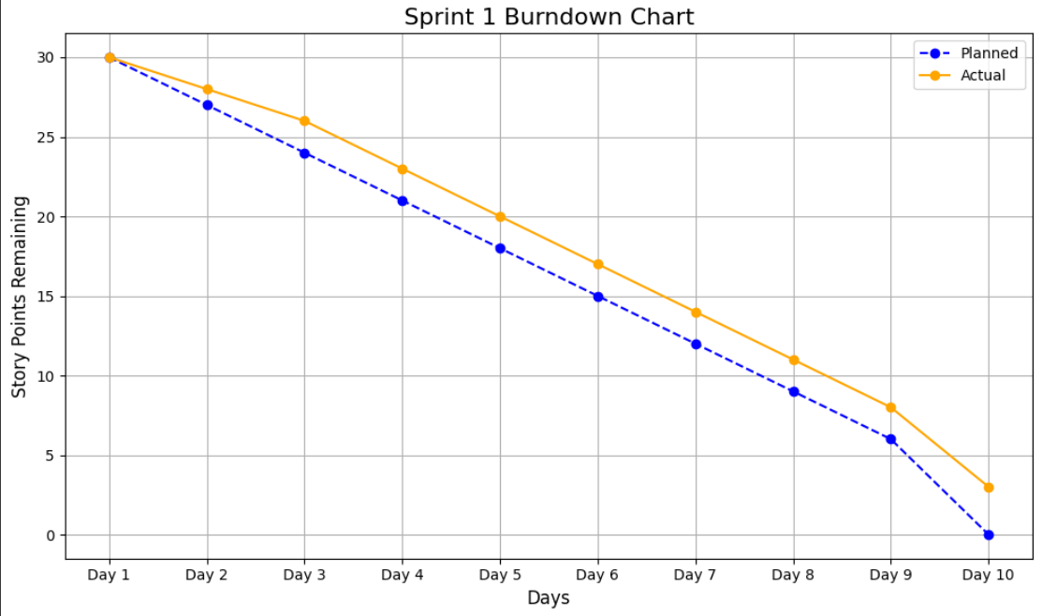

Sprint Review Meeting
Overview :
a. Date Time Stamp : 10 March 2025
b. Attendees :
Present | Absent
Anas Bin Rashid | -
Adan Malik | -
Hasnain Akhtar | -

Topics Discussed and Conclusions Reached :
- Reviewed completed user stories: US-1, US-2, US-3, US-10, US-27.
- Demonstrated working features: Registration, Login, Password Reset, Worker Login, Secure Access.
Conclusions :
- All high-priority user stories completed successfully.
- Minor bugs identified during testing.
Overall Duration : 1 hour
Sprint Retrospective Meeting
Retrospective Meeting : Iteration/Sprint #1
Overview :
c. Date Time Stamp : 11 March 2025
d. Attendees :
Present | Absent
Anas Bin Rashid | -
Adan Malik | -
Hasnain Akhtar | -

Retrospective Content :
Successes | To Improve | Actions and Suggestions
Completed all high-priority user stories. | Minor delays in integrating password reset functionality. | Allocate more time for testing in future sprints.
Strong collaboration among team members. | Communication gaps during task handovers. | Use Trello for better task tracking.
Well-documented codebase. | Limited focus on UI/UX. | Involve a designer for future sprints.

5. Definition of Done (DoD)
- All unit tests are written.
- The written code is documented.
- Code reviewed and approved by peers.
- Features tested in staging environment.
- No critical bugs reported.

6. Bug Report
Name About : Bug Report: Duplicate Email Registration
Expected Behavior : Users should not be able to register with an existing email.
Actual Behavior : The system allows duplicate email registrations.
Steps to Reproduce :
- Navigate to the registration page.
- Enter an email that already exists in the database.
- Submit the form.
Context / Environment : This issue is related to Sprint #1, User Story #1.
Possible Solutions :
- Add backend validation to check for duplicate emails.
- Display an error message on the frontend if the email exists.
Definition of Done (DoD) :
- Unit test written for email validation.
- Code documented.
- Issue resolved and tested in staging.
Date Time Stamp : 5 March 2025
Reported By : Adan Malik

7. Output
Tested Code Implementation
API Endpoint for User Registration (Node.js + Express.js)
app.post('/api/register', async (req, res) => {
try {
const { name, email, phone, password } = req.body;

// Validation
if (!name || !email || !phone || !password) {
return res.status(400).json({ error: 'All fields are required.' });
}

// Save to Database
const newUser = new UserModel({ name, email, phone, password });
await newUser.save();

res.status(201).json({ message: 'User registered successfully.' });
} catch (error) {
res.status(500).json({ error: 'Server error.' });
}
});

import React, { useState } from 'react';
import axios from 'axios';

const RegisterForm = () => {
const [user, setUser] = useState({ name: '', email: '', phone: '', password: '' });

const handleSubmit = async (e) => {
e.preventDefault();
try {
const response = await axios.post('/api/register', user);
alert(response.data.message);
} catch (error) {
console.error(error);
}
};

return (
<form onSubmit={handleSubmit}>
<input
type="text"
placeholder="Name"
value={user.name}
onChange={(e) => setUser({ ...user, name: e.target.value })}
/>
<input
type="email"
placeholder="Email"
value={user.email}
onChange={(e) => setUser({ ...user, email: e.target.value })}
/>
<input
type="text"
placeholder="Phone"
value={user.phone}
onChange={(e) => setUser({ ...user, phone: e.target.value })}
/>
<input
type="password"
placeholder="Password"
value={user.password}
onChange={(e) => setUser({ ...user, password: e.target.value })}
/>
<button type="submit">Register</button>
</form>
);
};

export default RegisterForm;

Katalon Studio Code

WebUI.openBrowser('')
WebUI.navigateToUrl('http://localhost:3000/register')

WebUI.setText(findTestObject('Object Repository/input_Name'), 'John Doe')
WebUI.setText(findTestObject('Object Repository/input_Email'), 'john.doe@example.com')
WebUI.setText(findTestObject('Object Repository/input_Phone'), '1234567890')
WebUI.setText(findTestObject('Object Repository/input_Password'), 'password123')
WebUI.click(findTestObject('Object Repository/button_Register'))

WebUI.verifyTextPresent('User registered successfully.', false)
WebUI.closeBrowser()

8. Project Planner and Gantt Chart
Project Planner
- Task 1: Set up project infrastructure (Day 1–2).
- Task 2: Implement user registration (Day 3–4).
- Task 3: Implement user login and password reset (Day 5–7).
- Task 4: Implement worker login and secure access (Day 8–10)

Gantt Chart
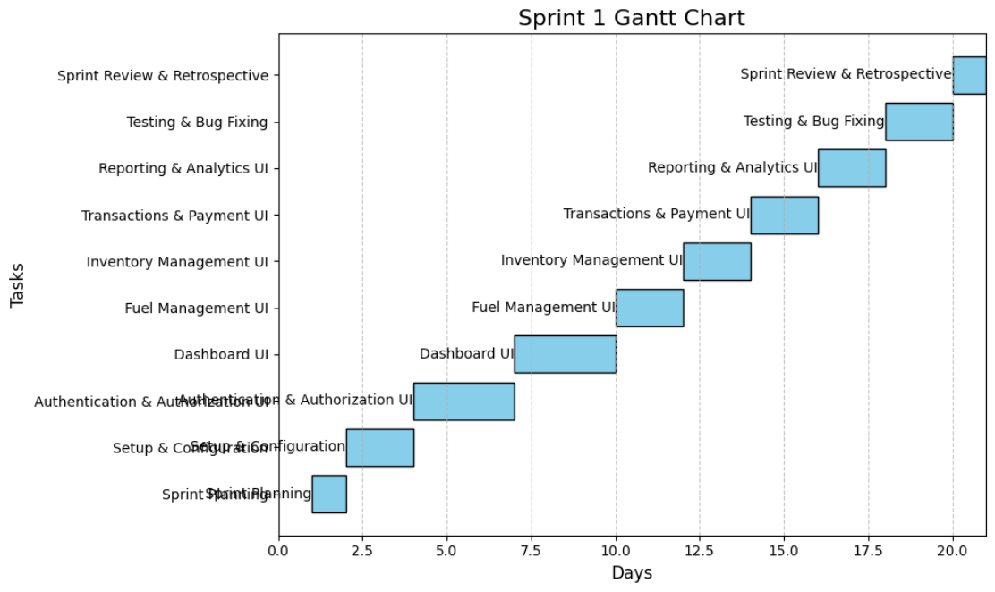
9. Trello Screenshots

Start of Sprint
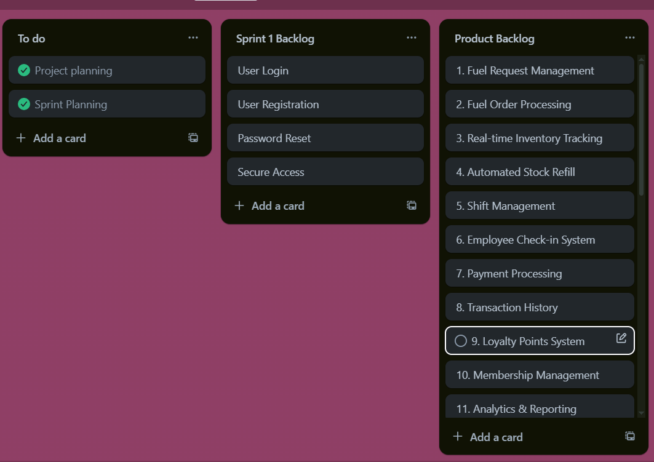

Middle of Sprint
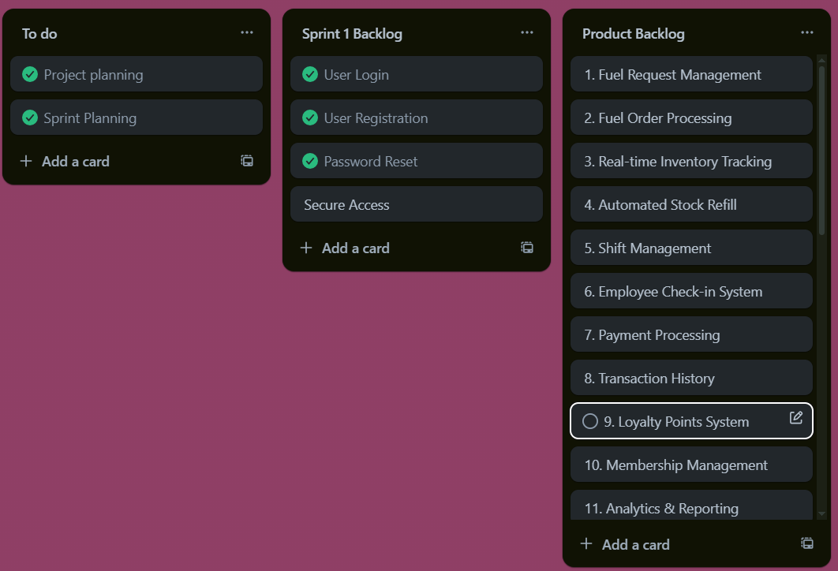

End of Sprint
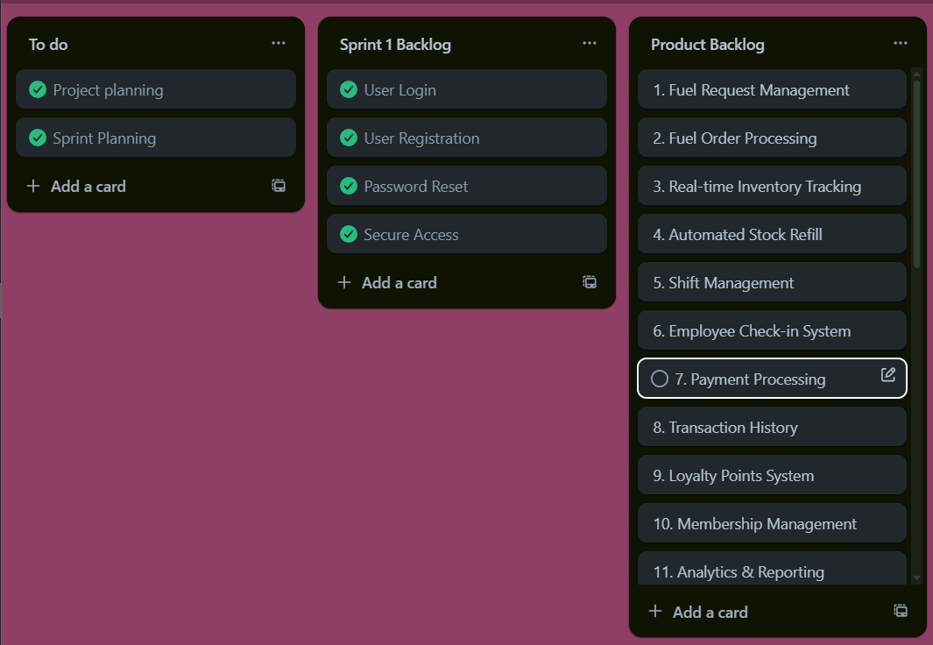

Scrum Master Activities and Leanings
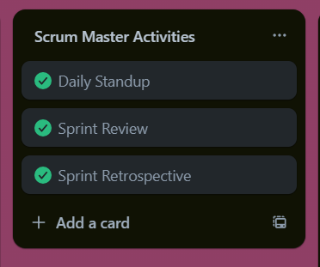
Topics Discussed and Conclusions Reached :
- Reviewed completed user stories: US-1, US-2, US-3, US-10, US-27.
- Demonstrated working features: Registration, Login, Password Reset, Worker Login, Secure Access.
Conclusions :
- All high-priority user stories completed successfully.
- Minor bugs identified during testing.

10. Burndown Charts

